Project 1

Title
Battleship

Course
CIS-17A

Section
42474

Due Date
April 18, 2018

Author
Mariia Gregory

Table of Contents

Introduction 3
1. Game Rules 3
2. Specifications 4
2.1 Inputs/Outputs 4
2.2 Structures 6
2.3 Pseudocode 6
2.4 Function descriptions 8
2.5 Flowcharts 9
2.4.1 setBrd and setCrds 10
2.4.2 collisn 11
2.4.3 shwGrid, takeGuess, and parseGuess 12
2.4.4 isHit, isSunk, and mrkSunk 13
2.4.5 main 14
3. Concepts Used 15
4. References 15
Conclusion 15

Introduction
As a midterm project, we were assigned to develop a text-based board game in C++, utilizing structures, pointers, binary file operations, and other concepts. I chose to develop a Battleship (also known as Sea Battle) because, first of all, I know how to play it, and, second, I already got ideas for its organization and functions from previous studying of the corresponding tutorial in JavaScript book. I adapted the web-paged game, written in JavaScript, to a text-based one written in C++, and I also changed some game features an added some new ones.

Game Rules
A user can play for both players, switching roles, or two users can play on one computer, switching turns.
A player A fires ships of player B by guessing their coordinates. Each guess results in “Missed”, “Hit”, or “Sunk”. Players fire at each other’s ships until all ship of one of the players are sunk. The player who sunk all enemy’s battleships is a winner. Player can play several rounds, until they get tired.
Every time the ship is sunk, the number of sunk ships is incremented and compared to the total number of ships. If the numbers are equal, the round is over.

Development Summary
Lines of Code | 362 |  | Blank Lines (White space) | 13
Comment Lines | 54 |  | Total Lines of Source File | 429

The project is written in C++ using NetBeans IDE 8.2 and, occasionally, Dev-C++ 5.11.

Specifications

Inputs/Outputs
After the game welcome title appears, the user is asked to enter the first player’s name. If the user just presses Enter, the default name, like “John” or “Mary,” is assigned. Then, the user is asked to enter a name of the second player, and the same order repeats.
After the user introduces both players by name, in the beginning, the program pauses until the user presses Enter, to start a game.
A player 1 is prompted for a ship coordinate, in a format A0 (letter-number). If the user enters something inadequate, or a coordinate is overboard, or this spot has already been fired at, the user is re-prompted until the valid coordinate is entered.
Then – “Fire!” If the enemy ship is hit, the spot is marked ‘X’ on the enemy’s board. If all the spots on a single ship have been hit, the ship is sunk, and all the sunk ship’s spots are marked ‘S’. If no enemy ship was hit, the spot is marked as missed, ‘-‘.
After each guess, the enemy’s board with changes (marks hit/miss/sunk) displays, and the program pauses again, until the user plays Enter. This gives users time to evaluate the situation, plan the strategy, and switch turns (if two players are playing).
After each round, the info on winner and number of guesses it took him or her to win, is written to a binary history file.
After each round, the user is given a choice to start a new round or to end the program. If user chooses to continue, he or she types ‘y’ or ‘Y’, and the new round starts. If user does not want to continue, he or she presses any other key, and the game results appear on the screen:
- history file contents – round number, winner name, number of guesses
- players’ profiles – player’s name, number of games played, number of games won, success rate (%, as games won / played.)

Sample screenshots (see the next page):

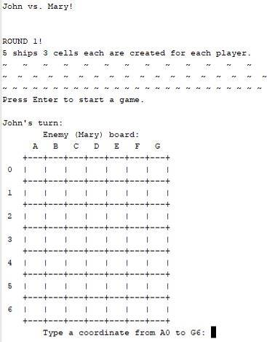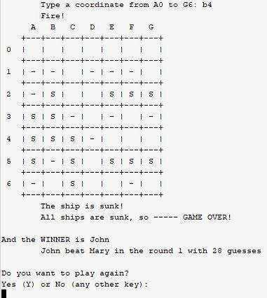

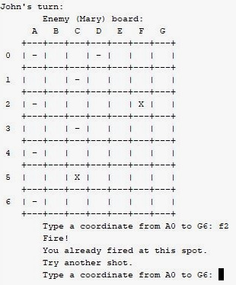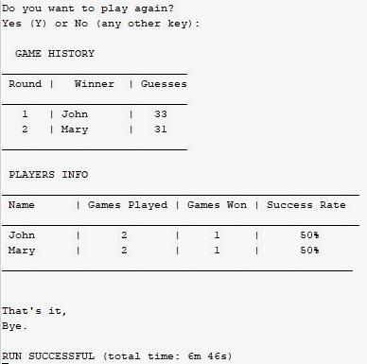

Structures
In this program, I used three structures:
Board | Ship | Player
size : short  grid : char**  numShips : short  ships : Ship*  numSunk : short | length : short  x : short  y : short  vert ; bool  hit : bool*  sunk : bool | name : char*  played : short  won : short

Pseudocode
Simplified, the game is built in the following way:

- Set random # generator
- Declare variables:
  - Create and open a history file object
  - Create 2 instances of Player { default name, 0 played, 0 won }
  - Declare “round” = 0 and char “again”
- For each player, prompt for a name and store a name
- Announce a round. Round++.
For each player:
  - Generate an instance of Board
    - Set board dimensions as N
    - Create a grid as 2D-array of N rows * N columns
    - Set # ships
    - Set # sunk ships to 0
  - allocate ships. For each ship:
    - set ship “length”
    - set direction: vertical or horizontal
    - set starting XY coordinate
    - Stretch “length” units down (for vertical) or right (if horizontal)
    - If overflows, adjust:
      - Vertical? Y + length over the grid ? Shift Y up
      - Horizontal ? X + length over the grid ? Shift X left
    - If collision with any other ship – restart from iii.
    - Set “hit” bool values of all ship spots to {false}
    - Set “sunk” to {false}
  - played++
  - declare # guesses = 0
Common variables of the round:
guess (pair of coordinates), won { false}, turn (bool / toggle {0/1})
- Guess and fire:
  - Display a player B’s board
  - Take a player A guess; # guesses++
loop until the guess is in a valid format, in a range, and hasn’t been fired at before
  - Parse the player’s A guess so that it represents a row and column numbers on a grid
  - Fire: compare the player’ guessed coordinates with the enemy ship locations
  - Hit ? Mark the hit spot ‘X’ on the grid.
If hit, all spots of this ship are hit ? If yes, sunk!
    - Sunk? Mark the whole ship ‘S’.
# sunk ++
# sunk == # ships ? Player won. Game over! Break.
Missed ? Mark the missed spot “-“ on the grid.
  - If game over, # games won ++
    - Announce a winner and # guesses
    - Write the round results to a history file.
    - Release memory for contents of both players’ boards
    - Play again ?
If yes, repeat from 4.
If no, close the history file.
If not, switch turns and repeat from 5.
- Reopen and read the history file.
Display its contents as a table: round #, winner name, # guesses
- Create another file and open it for output.
Write players’ profiles: name, # games played, # games won
Close the file.
- Reopen the file for input.
Create other 2 instances of players.
Read the file contents to the new instances of players
Close the file.
- Display statistics for players as a table:
name, # games played, # games won
Calculate the success rate for each player (#won/#played) and also display in a table
- Release memory allocated for both players.
- Say “Goodbye” and end the program.

Function Descriptions
The program consists of 14 functions, including main and excluding wave (non-functional part, design only, to imitate a sea wave.) Here are they:
main starts execution.Two Player and Board instances are created, setBrd is called, etc.
setBrd allocates memory for the board grid and ships, and calls setCrds.
setCrds sets a ship direction (vertical or horizontal) and its coordinates: starting x and y point and then, depending on a ship direction, down or to the right. If the ship overflows the board, x in a horizontal ship is shifted to the left, and y in a vertical ship is shifted up. After the ship is generated, collisn is called. If collisn returns true, the function is called recursively.
collisn checks if a generated ship location overlaps with any other ships.
shwGrid displays the board of the player, with ship marks: hit/miss/sunk, unharmed ships hidden by a whitespace.
takeGuess accepts player’s guess as XY coordinates, X – letter, Y – number.
parseGuess represents a guess as a pair of numeric XY values, as indices: X – column number, and Y – row number.
fire determined of a player hit or missed by calling isHit. If isHit returns true, isSunk is called. If isSunk returns true, mrkSunk is called.
isHit determines if the ship is hit by comparing a player guess with the ship locations.
isSunk check if all spots on a single ship are hit.
mrkSunk marks all the spots of a sunk ship on the board
wResult writes the game round results to a binary file: round number, winner, number of guesses
readHis opens the history file for input, reads its content, and displays the info as a table
setProf writes user info and results: names, number of games played, won, and a calculated success rate to a binary file. Then reads all the info back and displays it as a table.
destroy releases memory for board grid and ships. Called after each game round ends.

Flowcharts
I created flowcharts for all functions except wave, which was written exclusively for design purposes. Flowcharts for fire, readHis, and setProf are too long and do not fit in one page, so they are left out from this document. Flowcharts for wResult and destroy are too simple, so I saw no point in providing them here. However, all the flowcharts are available in image format as Functions.jpg and mainFC.jpg files attached to this assignment.
Please see the next page.

2.4.1 setBrd and setCrds
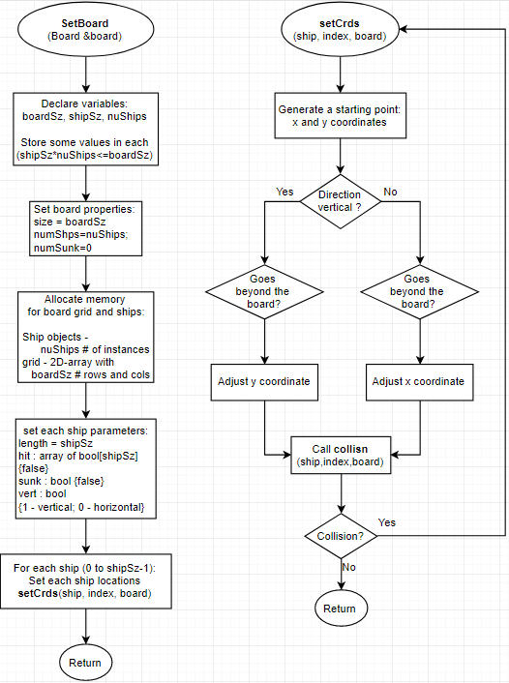

2.4.2 collisn
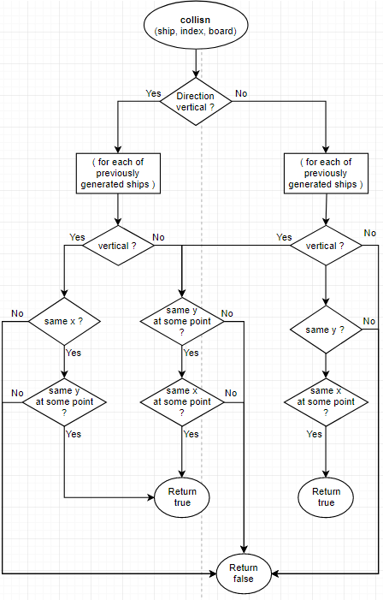

2.4.3 shwGrid, takeGuess, and parseGuess
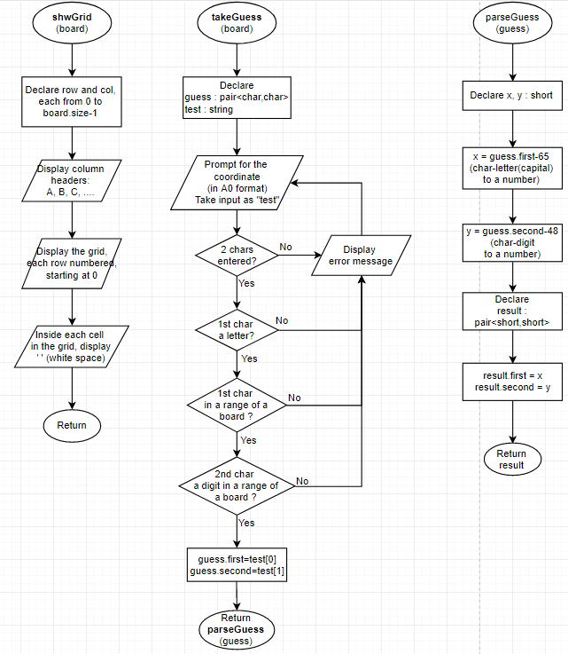

2.4.4 isHit, isSunk, and mrkSunk
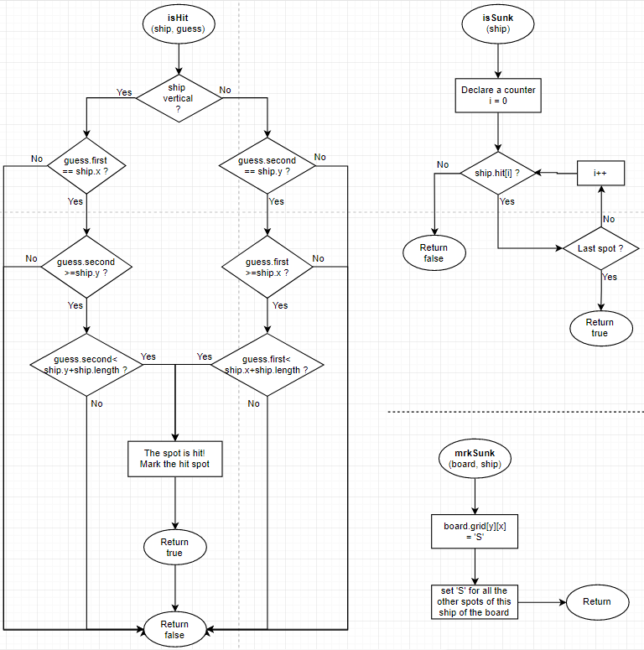

2.4.5 main
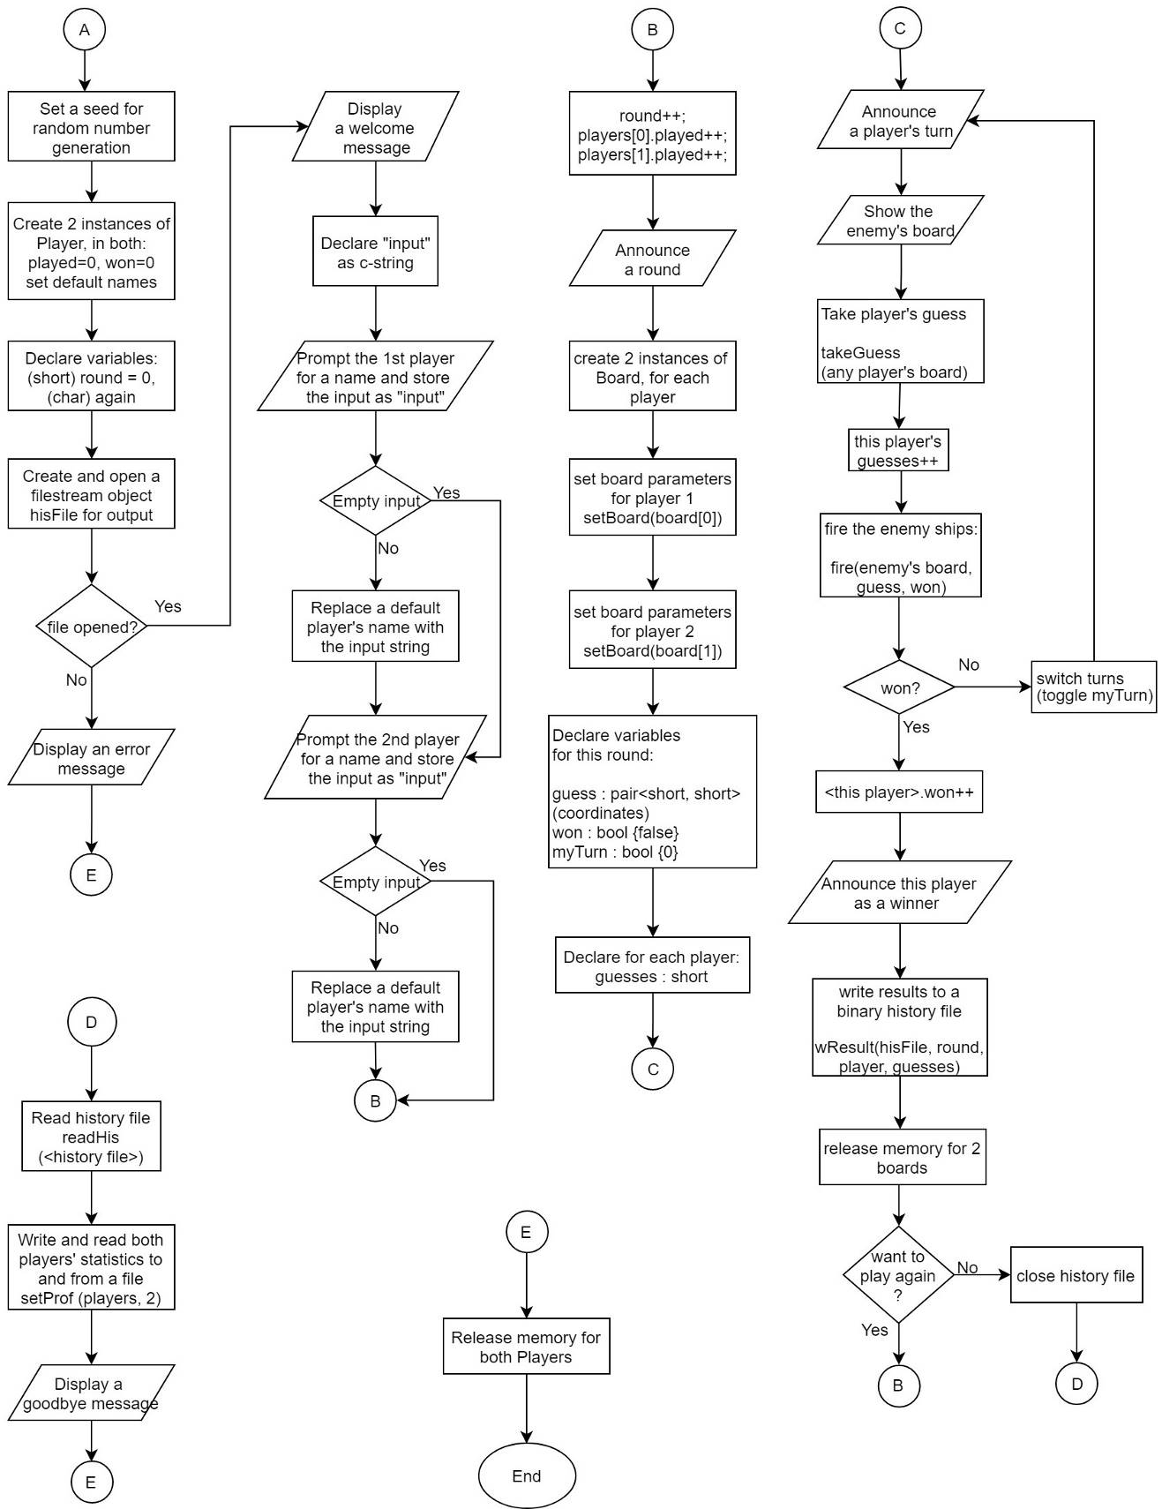

Concepts Used
- Structures
- Arrays (1- and 2-dimensional)
- Pointers and references
- Dynamic memory allocation
- Character arrays (c-strings) and string objects
- Binary files: writing to and reading from
- Pairs

References
- The idea is taken from the textbook:
Head First JavaScript Programming, by Robson and Freeman, 2014: 1st Edition, chapter 8.
- Instead of setting firm ship locations, like locs[3] = { “A1”, “A2”, “A3” },
I generated only the first XY coordinate, and then, depending on a ship direction, I continued its length down (if vertical) or right (if horizontal). This idea was first suggested by my colleague, Jason Lyllard, during our informal conversation.
- The idea of using a pair of values as a player’s guess came to me after I learned about this data type during a tutoring session. Actually, I was in a tutor role, but I learned this concept from my student, who had to use pairs for her CSC-5 assignment for winter 2018 semester.

Conclusion
This game is a simple and text-based, but it took me plenty of hours trying to make it work, learning and practicing with structures, pointers, and other tricky data types. My game is not the work of art, but hopefully, it can qualify as an entry-level programming project. Later, I expect to utilize classes with all their features and even apply graphics so that it can turn into a decent program.

